Event Name | Vocational Course on Fitness and Wellness
Dept. Name | Sports Department
Level | Different levels of students participated
Date of Event | 18th, 19th & 20th December 2025
Time of Event | 7 Am to 10 Am (3 hours per day)
Event purpose/motive | The primary purpose of organizing the Vocational Course on Fitness and Wellness was to provide students with practical, skill-based knowledge in the field of physical fitness, health management, and overall wellness. The program aimed to enhance employability skills, promote a healthy lifestyle, and create awareness about fitness as a professional career option.
No. of Participants | 50 students
Location | Box Cricket Area, Volleyball Ground
Expert details | Mr. Rahul Baraiya
Brief About Event | The Vocational Course on Fitness and Wellness was successfully conducted by the Sports Department from 18th to 20th December 2025 with the objective of equipping students with essential knowledge and practical skills related to fitness training and holistic wellness. The program was led by expert Mr. Rahul Baraiya, who possesses extensive experience in the field of fitness education and professional training.  During the three-day course, students were introduced to fundamental concepts of physical fitness, functional training, flexibility exercises, strength conditioning, and injury prevention. The expert emphasized the importance of correct posture, scientific exercise techniques, and consistency in maintaining physical health. Practical demonstrations and hands-on sessions enabled students to understand real-life applications of fitness principles.  The course also highlighted the significance of mental well-being, lifestyle management, and balanced nutrition as integral components of wellness. Interactive discussions encouraged students to ask questions and gain clarity on career opportunities in the fitness and wellness industry, including roles such as fitness trainer, wellness coach, and health instructor.  Overall, the vocational course proved to be highly informative and engaging. It motivated students to adopt fitness as a lifelong habit while also considering it as a viable professional pathway. The event successfully fulfilled its objective of promoting health awareness and skill development among students.
Event Coordinator Name | Dr. Kishor Anjara (Sports Coordinator)  Ms. Tulsi Mehta (Sports Coach)
Minutes of the event | • Welcome and introduction of the expert  • Orientation about fitness and wellness concepts  • Practical training sessions and demonstrations  • Interactive discussion and student queries  • Guidance on career opportunities in fitness  • Conclusion and feedback session
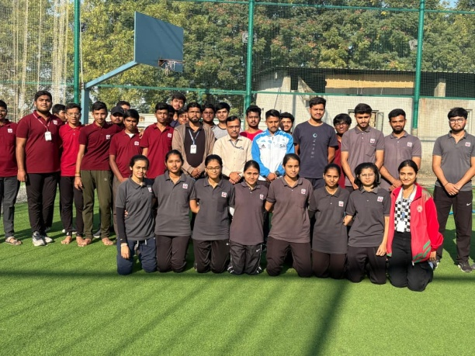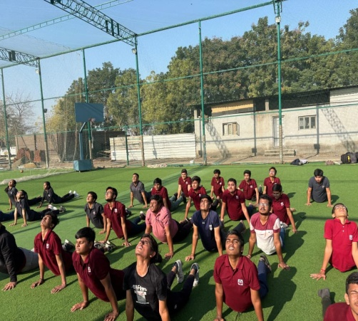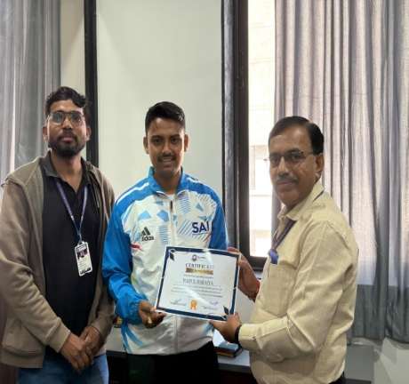
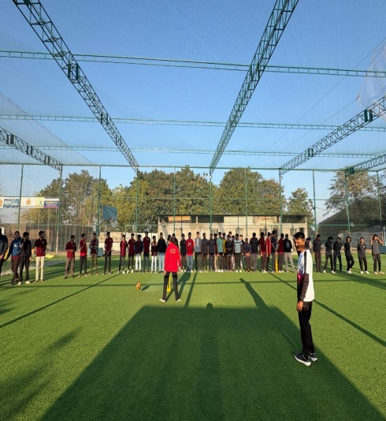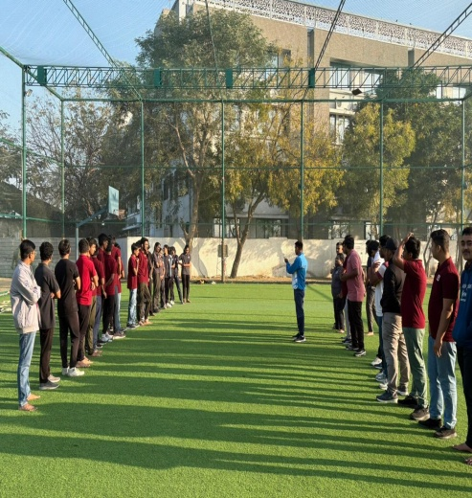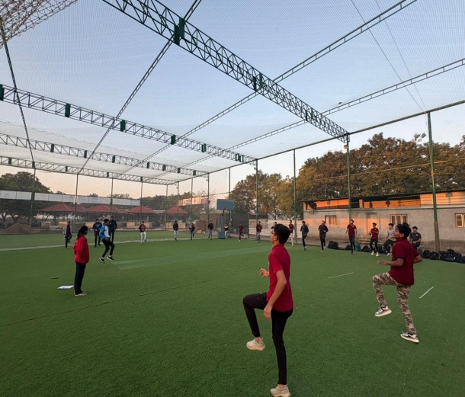
Department HOD Name | Dr. Viram Parmar
Remarks:
The event was conducted smoothly and achieved its intended objectives successfully

Event feedbacks by students :-
Students expressed positive feedback, stating that the sessions were practical, informative, and motivating. They appreciated the expert’s guidance and hands-on approach

Note: Event/Activity forms must be submitted within 2 days with Canva post/Reel. (Soft copy-word)

